|  |  |  |  |  |  |
| --- | --- | --- | --- | --- | --- |
| Date | 24-May-22 | | | Tester Name | Select Name |
| Environment | Select Environment | | | Login used |  |
| Operating System | Select OS | Version: | Update: | | |
| Software Used | Select Software | Version: | Update: | | |
| Select Software | Version: | Update: | | |
| Release version |  | | | | |
| Title |  | | | | |
| Test Type | Regression | | | | |
| Test Scenario |  | | | | |
|  |  | | | | |
| Expected Results |  | | | | |
| Pass/Fail | Select | | | JIRA# | N/A |

Describe your steps with screenshots:

1. Member

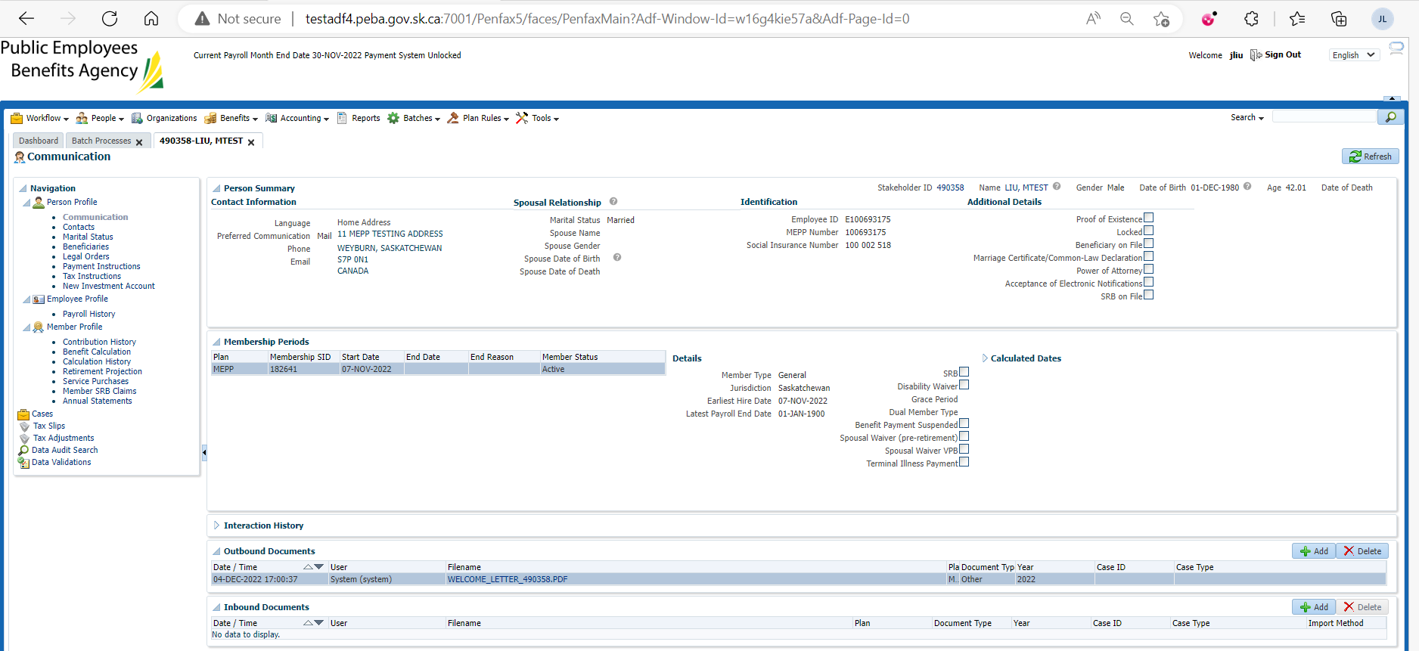

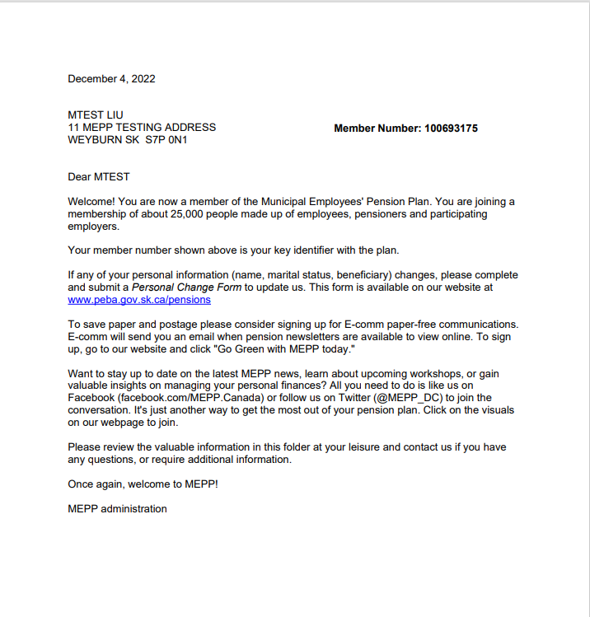

1. Sid= 214324

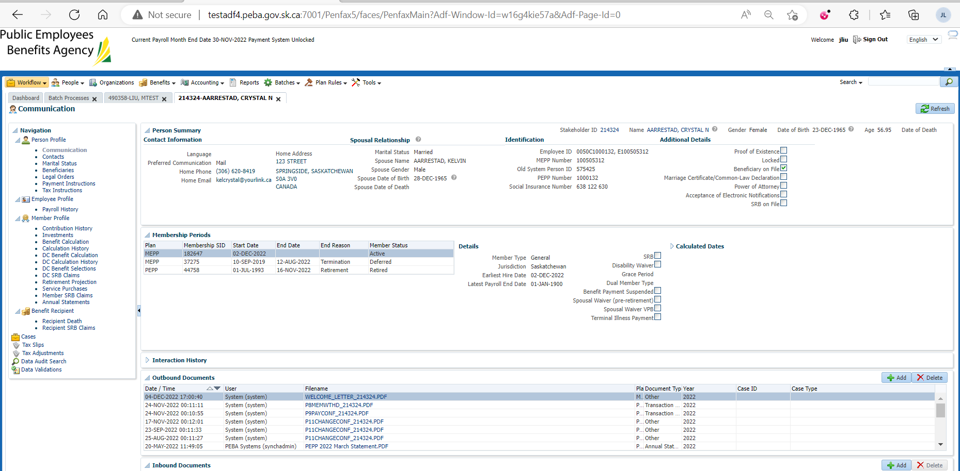

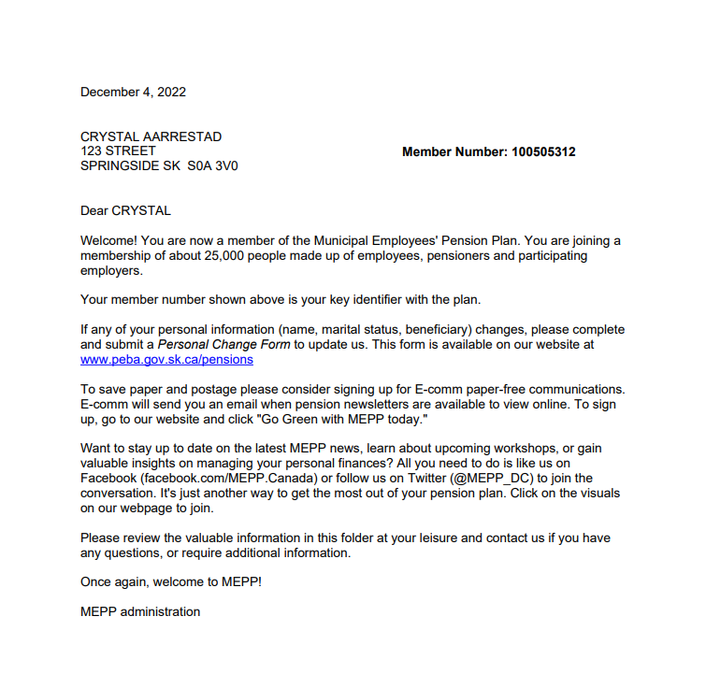

1. Sid = 102690

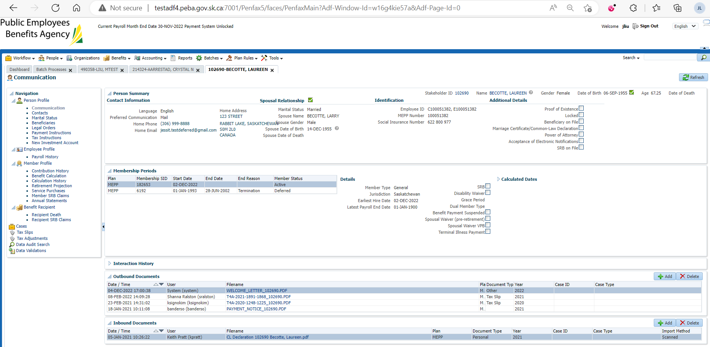

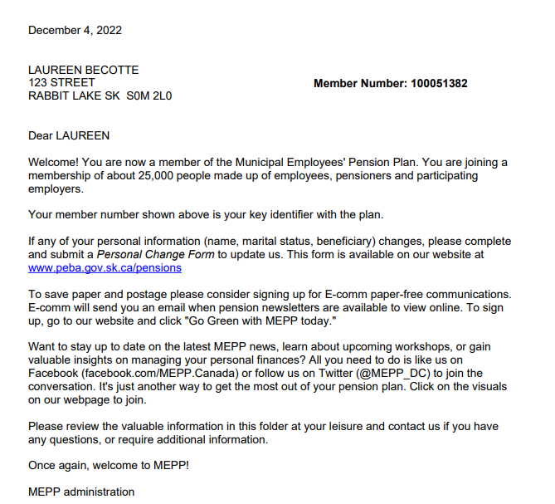

1. Sid =117138

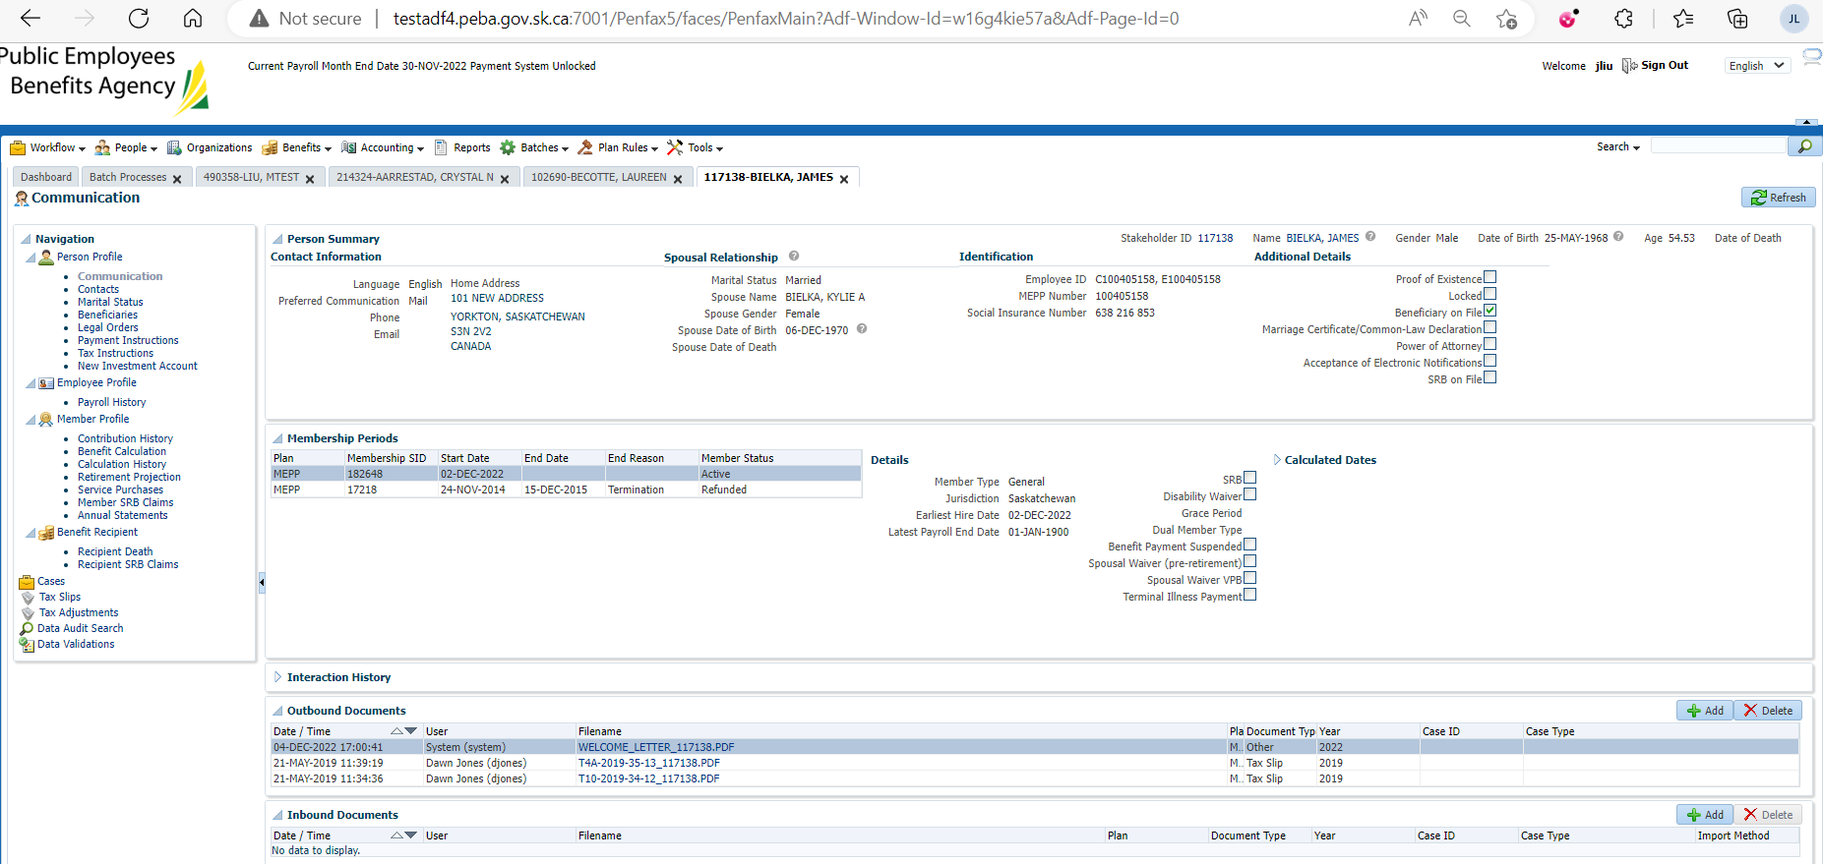

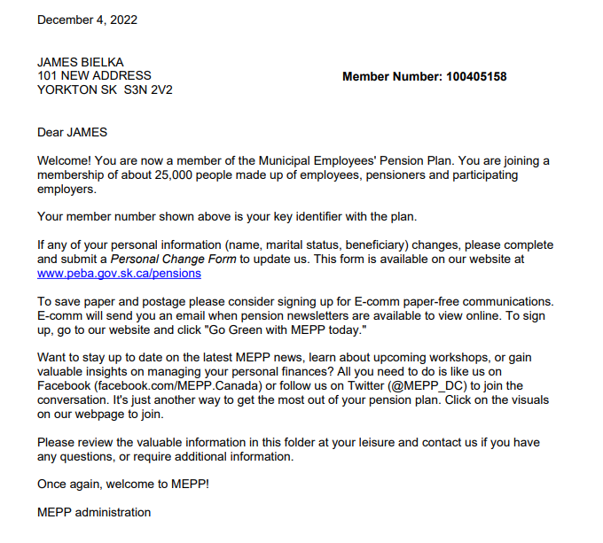

1. Sid =112882

